**10-10-23 notes**

Introduction to Matplotlib

Goals:

By the end of this lesson, you will be able to:

* Navigate Matplotlib's PyPlot interface.
* Create line charts, bar charts, pie charts, and scatter plots with Matplotlib.
* Change the appearance of plots in Matplotlib.
* Identify basic plot configuration options, such as xlim and ylim, with Matplotlib.

Numpy is Np

Matplotlib is plt

NumPy has some weird ‘Gotcha’ moments. They don’t care about spelling. The community has rioted, and they’ve still not changed things.

Example: instead of arrange, they have arrange with one r

**NJ Temperature solution:**

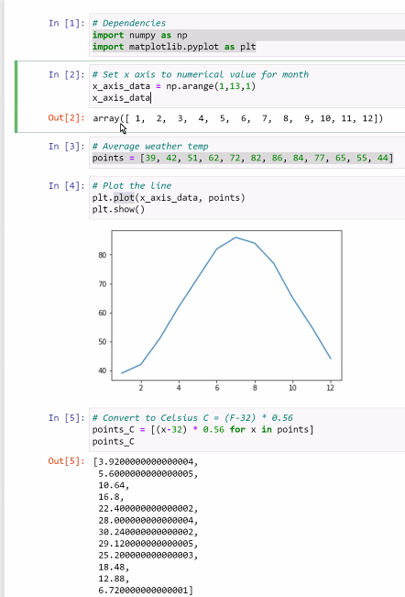

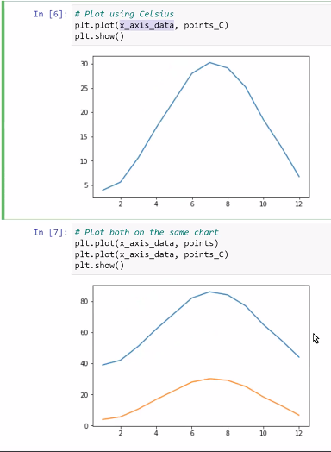

Review up till Manish said to do the NJ Temp activity.

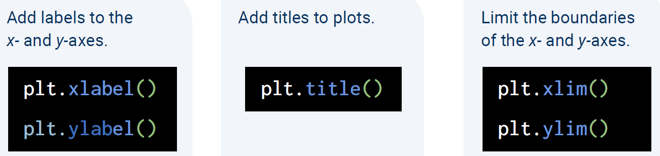

**Aesthetics Solution:**

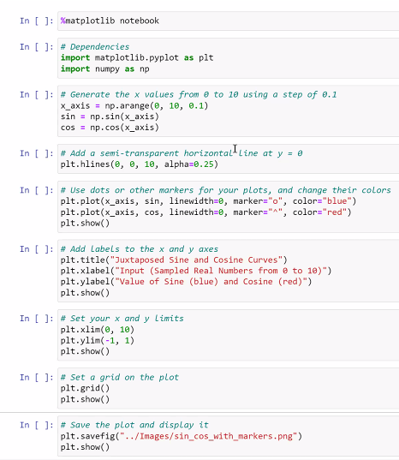

Plotting a legend (coaster speed activity):



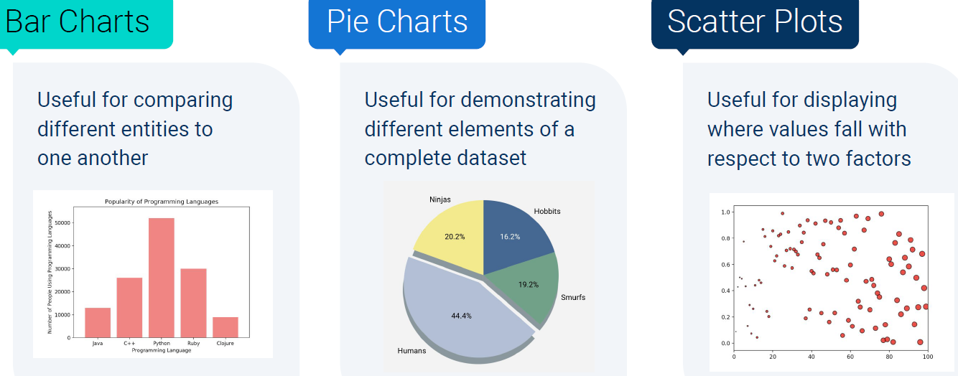

Univariate data refers to data with one variable, or one type of measurement.

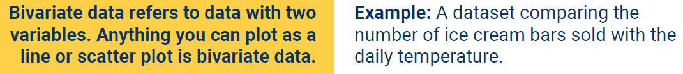

**Ins_BarCharts solution:**

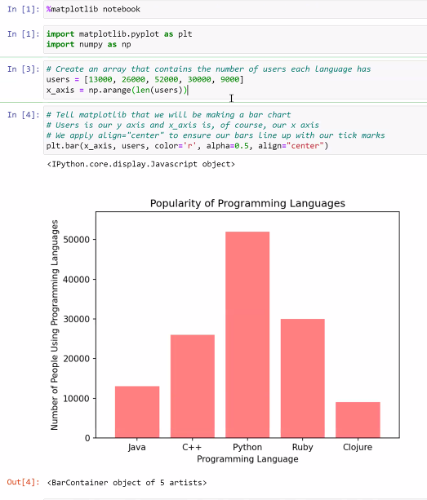

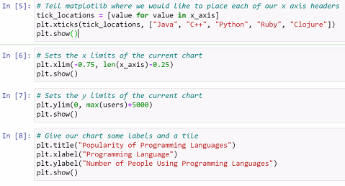

**Py_bars solution:**

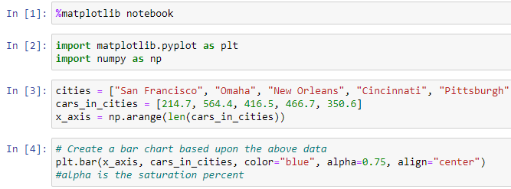

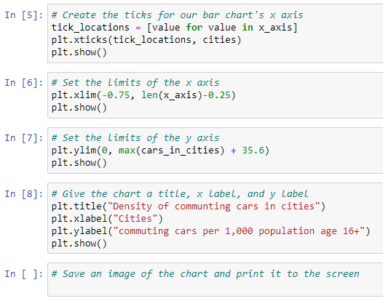



**Instructor Pie chart solution:**

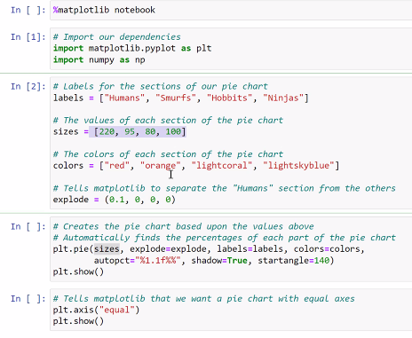

**Instructor Scatter Plots Solution:**



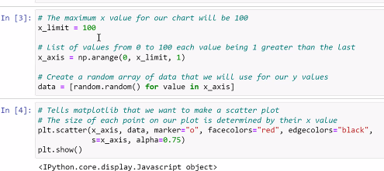

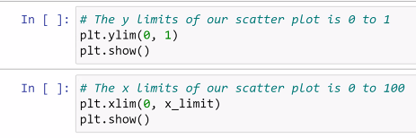

^ In In [3], the random process isn’t that random. It follows an algorithm.

**Avg state rain solution:**

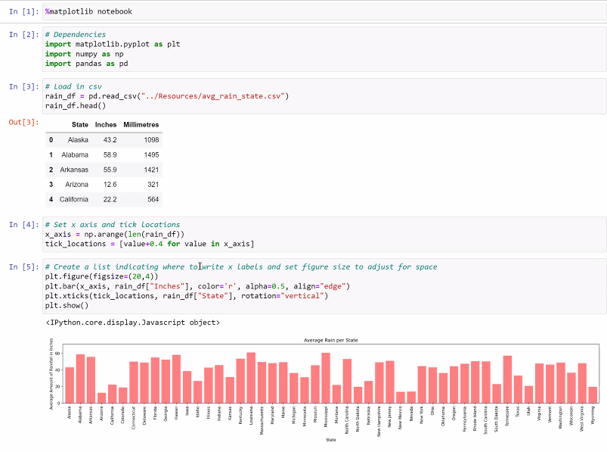

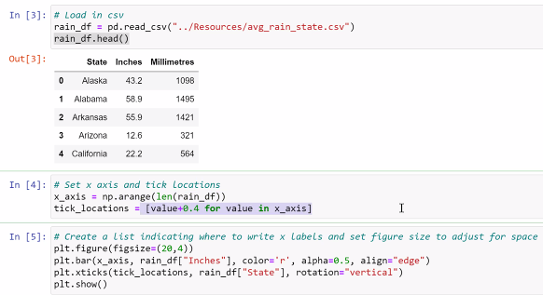



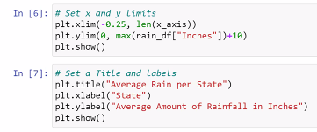

^ in In [5], rotation rotates the

^ in In [4]

Carson recommends Df.shape instead of Len function.

Google how it works. There are so many options for what to use.

